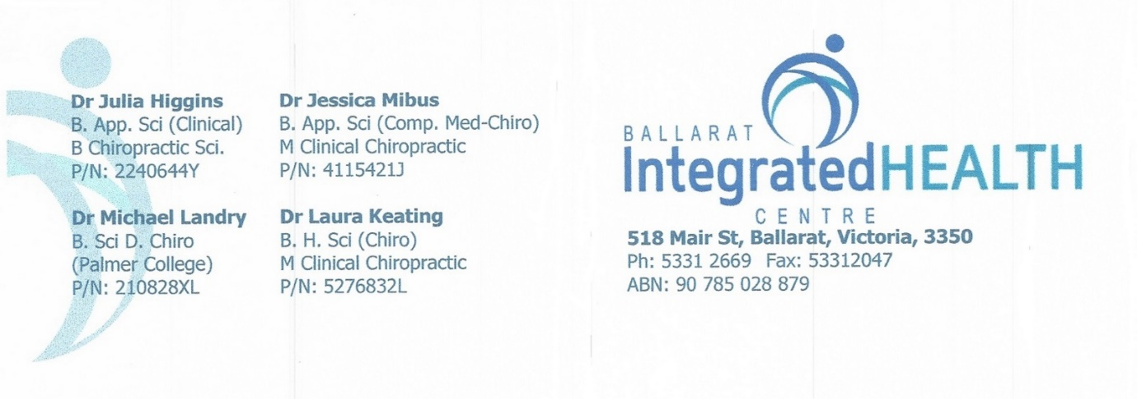

**What is Dry Needling?**

Dry needling is the insertion of a solid needle through the skin down into muscle. The needle differs from an injection as it is not hollow, so no substance (other than the needle itself) can be inserted into the body. Dry needling uses the same needles as Acupuncture and the same technique to tap them into your body. It differs from Acupuncture in the reasons they are used and the effects they aim to achieve. Acupuncture uses an ancient Eastern technique of stimulating different points on the body to ease pain and treat various health conditions. It is often used in conjunction with herbal remedies in Chinese medicine. Dry needling is a biomechanical technique that is used by musculoskeletal specialists to break down and heal trigger points (knots) in muscles.