Mr/Mrs/Miss/Ms First Name: ______________________ Surname: _______________________

Address: ________________________________________________________________________

Postcode: ____________________________________ Date of birth: _____/____/____________

Home phone: ____________________________ Mobile phone: ___________________________

Occupation_________________________________ Private Health Fund: Y_________ N________

Medicare Number: ____________________ref (___) Student Concession Y_________ N________

Pensioner: Y______ N_____ Card Number: ____________________________________________

Emergency contact name & phone: ___________________________________________________

Have you previously seen a Chiropractor: Yes/No How long ago? ___________________________

How did you hear about us? Google ___ Family ___ Dr___ Friend ___Other (who?) _____________

Work Cover: ____________________________ TAC: _____________________________________

Email address: ____________________________________________________________________

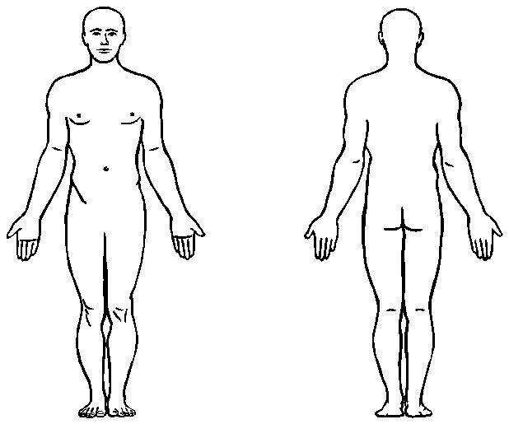

PLEASE DRAW ON THE DIAGRAM 🡪

* **For pain use XXX**
* **For tingles use ///**
* **For Numbness use 000**

If you have any medical conditions or taken any medications, please list them and describe what you take each one for: _______________________________________________________________________________

________________________________________________________________________________________________________________________________________________________________

If you have had an x-rays or scans taken of your spine, please list where and when they were taken. ________________________________________________________________________________________________________________________________________________________________

Any history of cosmetic implants or pacemaker surgery? Y­­­­­­ _________ N _________

**\*Please note that missed appointments with a minimum of 2 hours’ notice will be charged for.**

**Signature: ____________________________________________ Date: ____/____/__________**